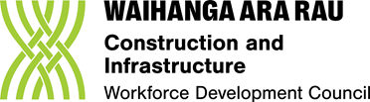
FEEDBACK FORM TTM
Skill standards and programme guidance
Question 1
Do the learning outcomes in the left-hand box describe the skills required to meet the description in the purpose statement?

NIW01 | MW01 | TTMWK
Yes ü No X | Yes ü No | Yes ü No
Comments (plain language, what is missing, relevance to TTM work, other?)

Question 2
Will the assessment criteria in the right-hand box make it easy for an Assessor to judge if a learner is competent?
NIW01 | MW01 | TTMWK
Yes ü No X | Yes ü No X | Yes ü No X
Comments (plain language, what is missing, relevance to TTM work, other?)

Question 3
Does the indicative content cover the key learning topics for each assessment criteria?
NIW01 | MW01 | TTMWK
Yes ü No X | Yes ü No X | Yes ü No X
Comments (plain language, what is missing, relevance to TTM work, other?)

Question 4
Is the industry information in the programme guidance accurate?
Comments (plain language, what is missing, relevance to TTM work, other?)

